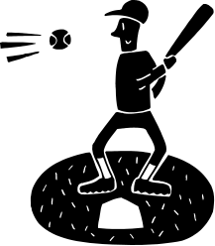
Friction as a Friend

Friction ____ help us in many ways.
• Friction between the ground ____ our shoes allows us to walk and run ___________ slipping over.
• The brakes on __ car rely on friction with the wheels to slow down ____ stop the car.
• Cars ____ prevented from skidding on roads ___ the friction between the road and ____ tyres.
• The friction between a match and a matchbox produces enough heat ___ ignite the match.
• The friction between a pencil and paper enables ___ to write and draw.
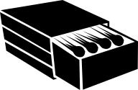
• Friction between ____ hands and a cricket bat allows us to hold ____ firmly.
without, a, are, our, can, us, it, to, the, or, by, and,

Friction ____ be a nuisance to us.
• Friction causes wear. Friction _________ moving parts of a machine such ___ a car engine can cause ______ to wear and prevent them ______ working properly.
• Friction makes __ difficult to keep objects moving. Friction between __ bookcase and the floor makes it difficult ___ slide.

• The heat produced ___ friction can be a disadvantage to ____. If _____ allow a rope to move quickly through our hands the friction between the rope and _____ hands can burn our hands.
as, to, from, we, our, can, a, by, them, it, between, us,

- What is friction?

- When are friction forces present?

- What does friction do to your shoes?

- How does friction help us?

- How can friction be a nuisance?

